**Kubernetes Failure Prediction**

Project Documentation

**1. Introduction**

Kubernetes is a widely adopted platform for deploying and managing containerized applications. However, failures in Kubernetes clusters can significantly impact application availability and performance. This project aims to build a machine learning model using a Random Forest Classifier to predict potential failures in a Kubernetes cluster. By analyzing system metrics and event logs, the model helps improve cluster reliability and minimize downtime.

**2. Objectives**

- Monitor and analyze Kubernetes failures.

- Train a machine learning model to predict failures based on system metrics.

- Improve cluster reliability and minimize downtime.

**3. Dataset Overview**

- Source: `kubernetes_final_dataset.csv`

- Features:

- CPU usage

- Memory usage

- Disk I/O

- Network latency

- Event logs

Target Variable: `event_type` (categorical variable representing failure types).

**4. Project Workflow**

4.1 Data Preprocessing

- Handle missing values by replacing them with zero.

- Encode categorical variables using `LabelEncoder`.

4.2 Feature Selection

- Select key metrics such as CPU, memory, disk, and network usage.

4.3 Data Splitting & Normalization

- Split the dataset into 80% training and 20% testing.

- Scale numerical features using `StandardScaler`.

4.4 Model Training

- Train a Random Forest Classifier with 100 estimators.

4.5 Model Evaluation

- Compute accuracy, precision, recall, and F1-score.

**5. Implementation**

5.1 Load & Preprocess Data

# Load dataset

df = pd.read_csv('kubernetes_final_dataset.csv')

# Handle missing values

df.fillna(0, inplace=True)

# Encode categorical variables

label_encoders = {}

for column in ['event_type', 'pod_status', 'deployment_strategy', 'scaling_policy', 'traffic_label']:

le = LabelEncoder()

df[column] = le.fit_transform(df[column])

label_encoders[column] = le

5.2 Train the Model

# Select features

features = ['cpu_usage', 'memory_usage', 'network_latency', 'disk_io']

X = df[features]

y = df['event_type']

# Split data into training and testing sets

X_train, X_test, y_train, y_test = train_test_split(X, y, test_size=0.2, random_state=42)

# Scale features

scaler = StandardScaler()

X_train = scaler.fit_transform(X_train)

X_test = scaler.transform(X_test)

# Train Random Forest model

model = RandomForestClassifier(n_estimators=100, random_state=42)

model.fit(X_train, y_train)

5.3 Model Evaluation

# Predict on test data

y_pred = model.predict(X_test)

# Evaluate model

print("Accuracy:", accuracy_score(y_test, y_pred))

print(classification_report(y_test, y_pred))

**6. Results**

- Accuracy: 32.4%

- Precision, Recall, and F1-score Analysis:

| Class | Precision | Recall | F1-score | Support |
| --- | --- | --- | --- | --- |
| 0 | 0.33 | 0.38 | 0.36 | 255 |
| 1 | 0.31 | 0.28 | 0.29 | 239 |
| 2 | 0.33 | 0.31 | 0.32 | 248 |

**7. Decision Tree Visualization**

The following tree represents the first decision tree from the Random Forest model:

# Plot the first decision tree from the Random Forest

plt.figure(figsize=(20, 10))

tree.plot_tree(model.estimators_[0], feature_names=features, filled=True, rounded=True)

plt.show()

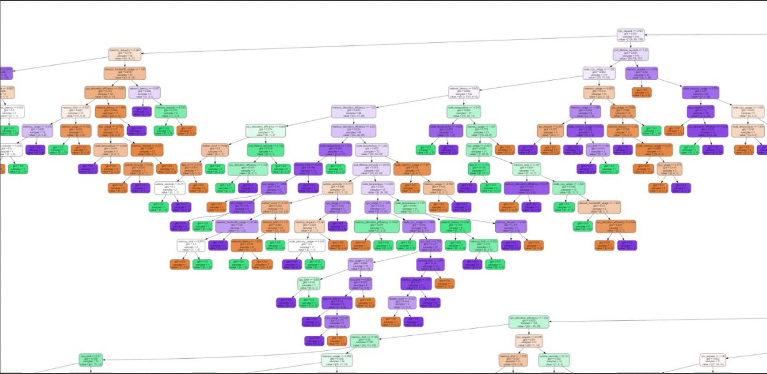

Example-

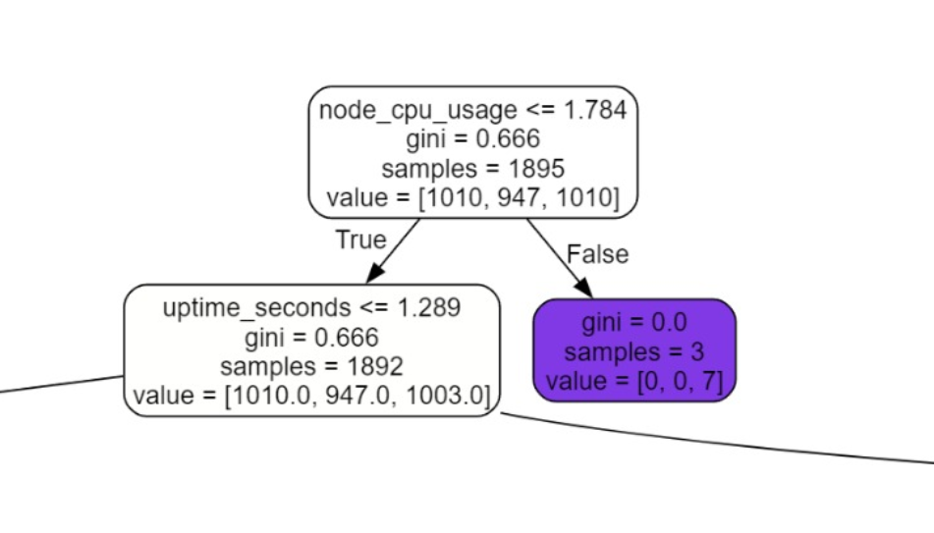

**8. Deployment & Future Improvements**

- Save the trained model using `joblib` for future use.

- Improve accuracy by tuning hyperparameters.

- Implement real-time failure detection in Kubernetes clusters.

Code:(for future use )

# Load the saved model and scaler

model = joblib.load('kubernetes_failure_prediction_model.pkl')

scaler = joblib.load('scaler.pkl')

# Use the model for predictions

new_predictions = model.predict(X_test)

**9. Conclusion**

- Successfully built a Kubernetes failure prediction model.

- Identified key resource usage metrics affecting failures.

- The model can be further improved for better accuracy.

**10. References**

- Scikit-Learn Documentation : [https://scikit-learn.org/stable/](https://scikit-learn.org/stable/)

- Kubernetes Official Docs: [https://kubernetes.io/docs/](https://kubernetes.io/docs/)

Images

1. Data Summary - output

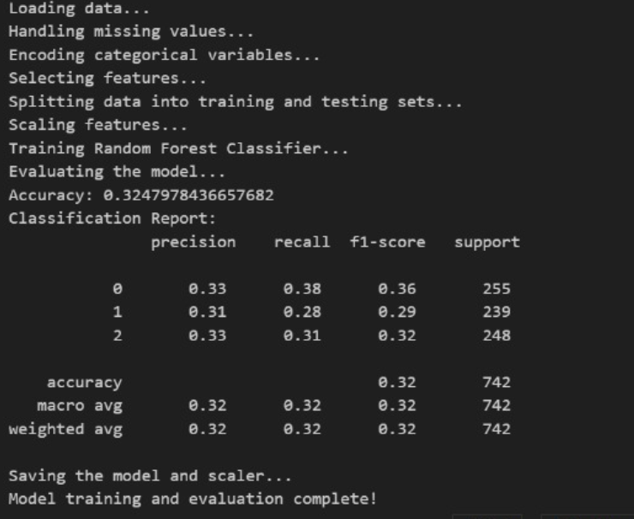

2. Model Evaluation

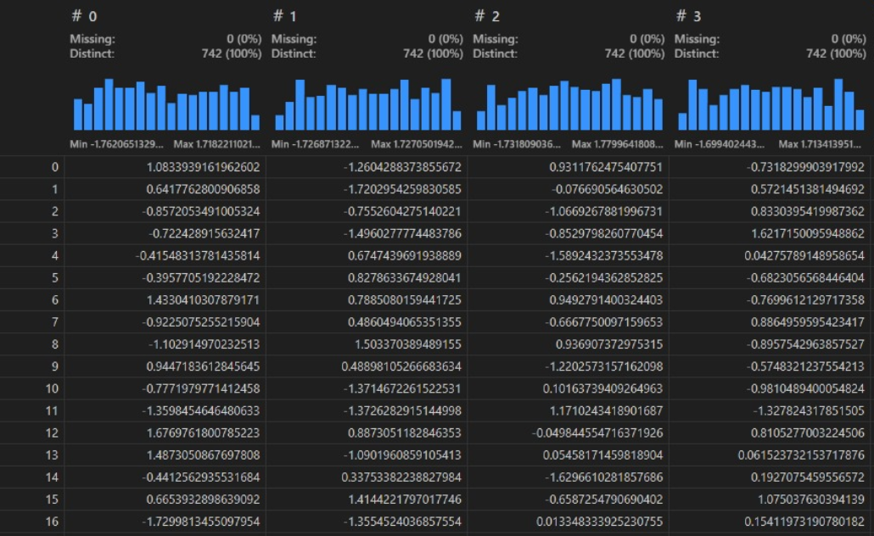

3. Data Wrangler

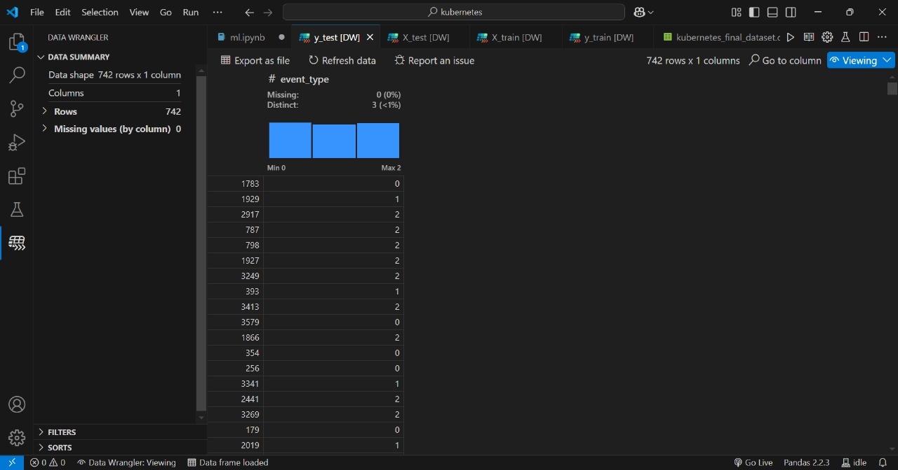

4. Explorer